Q1. Write a script to open the Firefox browser and open https://www.google.com/ URL.
Refer to Ques1.java in attached file
Q2. Write a script launch the Google Chrome browser and open https://www.google.com/ URL.
Refer to Ques2.java in attached file

Write the following scripts in any of your desired browsers-
Q3: Write a script to search the “To The New” string in google.
Refer to Ques3.java in attached file

Q4: Write a script to open http://www.tothenew.com/ and then navigate to the contact us page using 1) XPath 2) ID
Refer to Que4.java in attached file

Q5. Write a script to get the title of the “Contact Us” page.
Refer to Ques5.java in attached file

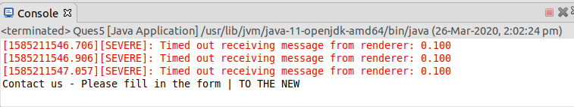

Q6. Write a script to get the url of the "Contact Us' page.
Refer to Ques6.java in attached file

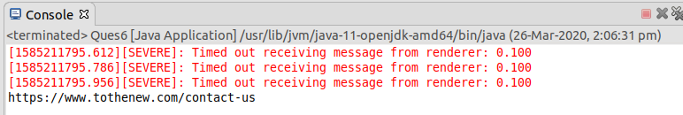
Q7: Write the disadvantages of selenium.
Ans. The limitations with selenium are as follows:-
- Doesn’t support automation of Windows applications.
- Lacks a good built-in reporting.
- Difficult while processing popups or frames.
- Difficult in coping with the page load and element load.
- Can’t automate a captcha and otp.
- It supports Web-based applications only.
- No Test Tool integration for Test Management
Q8: Difference between get() & navigate() method
Ans. driver.get() method is used to open an URL and it will wait till the whole page gets loaded. WebDriver will wait until the page has fully loaded before returning control to your test or script.For eg:
driver.get("http://www.google.com");

While driver.navigate.to() method navigates to an URL and It will not wait till the whole page gets loaded. It maintains the browser history and cookies, so we can use forward and backward button to navigate between the pages during the coding of Testcase.
driver.navigate().to("http://www.example.com");
driver.navigate().refresh();
driver.navigate().forward();
driver.navigate().back();

Q9. What is the difference between Selenium RC & Selenium WebDriver.
Ans. WebDriver is a web automation framework that allows you to execute your tests against different browsers, not just Firefox, Chrome (unlike Selenium IDE).WebDriver also enables you to use a programming language in creating your test scripts (not possible in Selenium IDE).
You can now use conditional operations like if-then-else or switch-case. You can also perform looping like do-while.
Selenium RC is an important component in the Selenium test suite. It is a testing framework that enables a QA or a developer to write test cases in any programming language in order to automate UI tests for web applications against any HTTP website.
Selenium RC comprises of two parts:
- Client libraries for the preferred computer language
- A server that launches and kills browsers automatically
Difference Between them:
However, Selenium WebDriver’s architecture is simpler than that of Selenium RC. Unlike Selenium RC, it does not involve any proxy server and it controls the browser directly from the OS (Operating System) level. This entails a significant reduction in complexity.
Note: Selenium WebDriver is more efficient and faster compared to RC. However, RC has an advantage over WebDriver in terms of report generations as the results are generated automatically in the form of an HTML file. This feature is not available for WebDriver.
Q10. What are locators & types of locators in selenium
Ans. Locator is a command that tells Selenium IDE which GUI elements ( say Text Box, Buttons, Check Boxes etc) its needs to operate on. Identification of correct GUI elements is a prerequisite to creating an automation script.

Different types of Locators in Selenium are as follows:
- ID - findElement(By.id("IdName"))
- Name - findElement(By.name("Name"))
- Class Name - findElement(By.className("Element Class"))
- Tag Name - findElement(By.tagName("HTML Tag Name"))
- Link Text & Partial Link Text - findElement(By.partialLinkText("partialLinkText"))
- CSS Selector - findElement(By.cssSelector(tag#id)) | findElement(By.cssSelector(tag.class))
- XPath - findElement(By.xpath("XPath"))

Q11. Write an automation script for filling all fields of the registration page. (Registration.html)
a- Validate that Refresh button is disabled.
b- Validate that your respective gender is selected or not.
c- Validate that header of the registration page is Automation Demo Site.
d- Validate that title of the page is Register.
Refer to Ques11.java in attached file

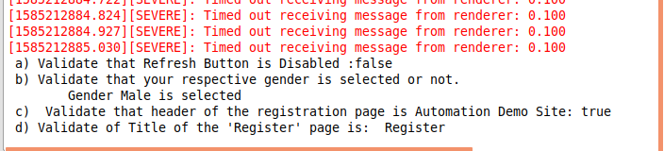
Q12. Write an automation script for filling FirstName, LastName & Email address field with the help of name locator. (Registration.html)
Refer to Ques12.java in attached file
